INFORMATION TECHNOLOGY
Paper Two memo
June 2013
KZN – DEPARTMENT OF EDUCATION

GRADE 11

TIME: 2 hours TOTAL: 100

INSTRUCTIONS AND INFORMATION:

- This paper consists of 6 questions and 7 pages of print.
- Answer ALL questions and write neatly.
- Number your answers exactly as the questions are numbered.

SECTION A
QUESTION 1
MULTIPLE CHOICE QUESTIONS [10]
Choose the appropriate alternative
1.1 Which type of cable is still used as TV cables and also used on some older networks?
A Fibre Optic cable
B Co-axial cable
C Shielded Twisted Pair cable
D Unshielded Twisted Pair cable
1.2 Which one of the following combination of components is found on the motherboard?
A Printer, Keyboard, Busses
B CPU, Busses, Mouse
C Hard Drive, System Clock, RAM
D CPU, RAM, ROM, Cache memory
1.3 Which device connects networks over longer distances when the signal strength weakens (attenuation)
and must be boosted?
A Modem
B Hub
C Router
D Repeater
1.4 Which of the following is not a typical example of a software program?
A Monitor
B Norton's Antivirus
C Internet Explorer
D MS Paint
1.5 What device is used to provide limited alternative power in the event of a power failure?
A UPS
B Modem
C Bluetooth Dongle
D Network Card

1.6 Magnetic fields can influence two cables if they are close to one another. This leads to data corruption or loss of
data. What is this phenomenon called?
A. Attenuation
B. Electro-magnetic interference
C. Eavesdropping
D. Crosstalk.
1.7 Which statement regarding CD-RW / DVD Rom drive is TRUE?
A The drive can read and write information to a DVD but can only read data from a CD
B The drive can only write data to a CD but can read and write data to a DVD
C The drive can read and write data to a CD but can only read data from a DVD
D The drive can read and write data on both a DVD and a CD

1.8 To switch on a computer in safe mode means
- No other person can obtain entry to the computer without a password.
- viruses cannot harm the computer
- All the drivers are loaded to repair faulty devices.
D. that only the minimum number of drivers is loaded.

1.9 The ALU is...
A the Amalgamated Linux Unix environment
B a register which stores arithmetic data
C a unit which performs mathematical calculation
D the way characters are represented in Unicode
1.10 The System Clock...
A is found on the desktop in the right hand corner
B is a quartz crystal in a chip on the motherboard
C is not necessarily needed to run the computer
D controls the speed for copying DVD's (10)

Question 2 [5]
Matching Question
Match Column A with Column B
Write down only the number and the letter corresponding to the answer of your choice, for example: 1.1 E

Column A |  | Column B
2.1. | Software that records things ranging from computer specifications to web sites visited and returns the information back to the creator of the software | F | Spyware
2.2 | The time taken for the read/write head on the disk to position itself on the correct sector | G | Seek Time
2.3 | A new interface for connecting peripheral devices to a computer via an expansion board | B | Thunderbolt
2.4 | Personal information is misused when someone else poses as you electronically | A | Identity Theft
2.5 | A device that conducts and disperses heat commonly produced by electronic equipment and components | E | Heat Sink

SECTION B
QUESTION 3 [20]
SYSTEM SOFTWARE
Answer the questions that follow.

Twilight Agency wishes to upgrade the current systems by purchasing newer computers or upgrading the components of the existing computers. You and your team of computer technicians were hired to advise and implement the action plan that Twilight Agency has put forth.

3.1 | A Staff member asks you if the company should upgrade from Windows XP to the latest operating system. You were asked to advise on issues regarding hardware and software if this upgrade was possible.
3.1.1 | The computers hard drive that used to work with Windows XP, no longer works with the newer operating system. Give a possible answer why this may be so.  It would be required to install the drivers for the new software  OR  It could be formatted using NTFS which has security implications. | (2)
3.1.2 | What is an operating system?  An OS is a collection of many programs.  The OS provides a user interface for a person to control computer operations. | (3)
3.1.3 | List 3 functions of a computers operating system.  - provides an interface  - manages processes and tasks  - manages memory  - manages input and output  - manages the disk/s etc.  Any 3 answers | (3)
3.1.4 | One of the essential functions of an operating system is process management. What is process management?  Process management is the task of making sure that each process gets enough CPU time and access to memory, storage and other hardware so that it can work without interfering with, or being interfered with, by other processes. | (2)
3.1.5 | Where is an operating system stored?  Hard Drive | (1)
3.1.6 | Briefly discuss how the operating system gets loaded when the computer is switched on.  - the processor chip finds the ROM chip that contains the BIOS  - the BIOS executes a series of tests to make sure the computer hardware is connected properly and operating correctly. This is the POST check, that will check various system components.  - The POST results are compared to the data in the CMOS chip, if successful, the BIOS searches for the OS, once located it is loaded into the RAM from storage and executed.  - The OS in memory takes control of the computer and loads the configuration information. | (3)
3.2 | Computers have the ability to multitasking and multi-process which can take place in a computer system with a single CPU. Briefly explain how this is possible?  Multitasking can take place with a single (or multiple) processor, and can be used to allocate  CPU time to each of the active programs, so that it appears that the computer is  performing more than one task at the same time.  Multiprocessing, however, only takes place when the operating system divides the programs  or threads or processes between more than one physical CPU. | (4)
3.3 | Task Manager in windows shows a lot of useful data in terms of resources and processes that are currently running. The screenshot shows that there are 1103 threads active. Define what a Thread is and give an example.  A thread is a part of a larger program that runs independently but simultaneously with other  parts of the same program.  Example: Threads allow a word processor to automatically check your spelling and grammar  while you type. | (2)

QUESTION 4
HARDWARE/SOFTWARE/COMPUTER ARCHITECTURE [35]

4.1 When upgrading, Discuss the 3 most important hardware to consider that will improve the overall performance of your computer. Motivate your answer. (6)
a) RAM – The more memory, the faster your pc
b) Storage devices –Hard Drive - The larger the storage capacity, the more information can be stored
c) CPU – the faster the CPU, the faster instructions are processed.

  - What is meant by “Dual Core CPU” in advert 2 (2)

The physical chip contains two real, complete and functioning CPUs.

4.3 The head of the IT department of Twilight Agency suggests that purchasing new motherboard for
the computers will save on costs rather purchasing new PC. He has heard of a modular designed
motherboard.

4.3.1 Briefly explain what a motherboard is and its function in a computer? (3)
The motherboard provides connectors to allow other circuits (CPU, RAM, etc.) to connect to it.
It ensures that all components of the computer can communicate with one another.
It distributes power to the parts that connect to it.

    - State TWO components of the motherboard and explain why explain of those components play a vital role in the computer (4)
a) Processor (CPU)
Interprets and carries out the basic instructions that operate the computer. This component impacts the overall computing power and manages most of the computers operations.
b) Memory
Consists of electronic components that store instructions waiting to be executed by the processor, and data needed by those instructions and the results of processed data.
c) Storage
Known as the secondary storage. Most computers have at least 2 storage devices (Hard drive & Optical Drives).
d) Expansion Cards plugged into expansion slots
These are cards that serve a function on your computer like providing sound or network connections. The slots are integrated into the motherboard.
e) Power Supply
This controls the main fan which cools the components of the system. It plays an important role and should be considered when upgrading as a poor power supply can cause your system to crash and bad sectors to appear on the hard drive. This generates power to the motherboard components.

4.3.3 What does the term Modular design mean? (2)
The term modular design refers to the fact that the computer is made up of many parts or ‘modules’ that can be added together.

4.3.4 State 2 advantages of a modular design? (2)
The slots and connectors on the motherboard allow you to plug different components in and
therefore you can change how your computer is configured.
It is therefore it easy to repair the computer by replacing a broken or faulty part.
It makes it easier to upgrade the computer by adding new parts or replacing existing ones with more powerful versions.
Any 2 answers
  - The older computers could have had contained cache memory. Briefly define the term cache memory and
explain how it works. (3)
Block of data and instructions that the CPU probably
needs next will be fetched from RAM & placed in cache
memory
When CPU requires data/instructions cache is searched
first (because cache matches speed of CPU)
If data/instructions needed is not found, new data &
instructions are fetched from RAM
  - One of the team members suggests that at least one computer should be fitted with a Firewire port.
Briefly describe the purpose of a Firewire port? (2)
It is used to connect devices such as digital video cameras to a PC.
  - Modern computers generally support the concept of ‘plug and play’. Briefly explain the meaning of this concept.(2)
New device can be connected to a PC and the OS will detect it and query it automatically.
  - The company also requires a scanner so that the client’s documentation can be scanned. After the scanner was connected to a computer, a message indicating that the driver for the scanner is required.
4.7.1 What is a driver? (1)
Drivers are small programs which enable communication between the operating system and hardware devices to take place.
4.7.2 How can this problem be solved? (1)
Install the correct drivers for this device.
4.8 All computers make use of virtual memory when running software
4.8.1 Briefly describe what virtual memory is. (1)
A computer can run out of RAM when executing an application
The operating system makes use of virtual memory to address this problem.
The virtual memory extends the number of addresses that RAM has and requires “pages” to be swapped between RAM and the hard disk.

    - Name two advantages of virtual memory (2)
a) a program is no loner limited by the size of physical memory that is available
b) because each program may take less physical memory, more programs can be run at the same time.

4.9 Many different processing techniques have been developed over the years to help the operating system and the CPU perform faster and more efficiently. Briefly describe the following processing techniques:
4.9.1. Multiprocessing (2)
multiprocessing : several programs can run simultaneously on different CPU’s – unlike multitasking in which only one program is actually being processed at any given moment because the program all share one CPU.

4.9.2 Hyperthreading (2)
hyperthreading : enables different threads in a program to share the use of one CPU by simulating two execution units in the one CPU chip.

QUESTION 5 [15]
NETWORKS

Romano Computing sets up computer laboratories and networks and offers their clients a maintenance program. Your manager approaches Romano computing company about setting up a network for your company.

5.1 | Explain TWO advantages of having a network?  Sharing of hardware  Sharing software  Faster distribution of information  Centralisation of data  Making backups easier  Cost effective  Improves communication  Shares internet connection  Improves security  Any two answers | (2)
5.2 | The manager wishes to implement a client server network. Give TWO reasons why a Client Server network may not be such a good choice for the work place.  Requires a network-oriented operating system OR requires network software  Cost with a valid reason.  The network is dysfunctional if the server does not work. | (2)
5.3 | Security is a major concern on a company’s network. Romano suggests we must employ a network administer. Explain what the role of a network administer is.  Setup of users' rights and privileges to establish privacy and security for users  Monitor suspicious activities on the network  Managing accounts or delete accounts or creates accounts Setting up a password on an account  Ensures that software is updated on a regular basis.  Controlling Internet access  Any two | (2)
5.4 | There are various topologies that can be implemented in a Network. Which type of topology would you recommend to implement in the company. Motivate your answer. | (2)
 | Star topology- as a star topology requires a central device that connects each PC. Pc’s are easily added on without affecting the network.
5.5 | List the components that make up a network. | (2)
PC
Cables
NIC
A Central device
Any two
5.6 | Name the TWO functions of a Switch? | (2)
Connects several devices in a network.
Can detect errors and isolate the error so that the network can still be functional
Can send data to the required destination on the network or chooses the correct / best path to follow OR controls / reduces traffic OR manages the bandwidth OR improves security due to correct choice of path.
Regenerates and amplifies signals
5.7 | Your CEO would like to have a wireless network instead of one using cables. He wants WiFi to be installed.  5.7.1 Explain the term WiFi.  It uses radio waves to provide wireless high- speed Internet and network connections that connect two or more devices / network / communication devices  5.7.2 If the WiFi technology is implemented, name the TWO devices that will be required to facilitate WiFi technology?  WiFi cards  Wireless router OR router  Wireless Access point  Antennae | (1)  (2)
 |  | (15)

SECTION C
QUESTION 6
SOFTWARE DEVELOPMENT AND PROGRAMMING [15]
Below is a screen dump of a GUI from the software developed to calculate the cost per a car entering the KUNA MATATA Game Reserve. Study the GUI screen and then answer the questions that follow.
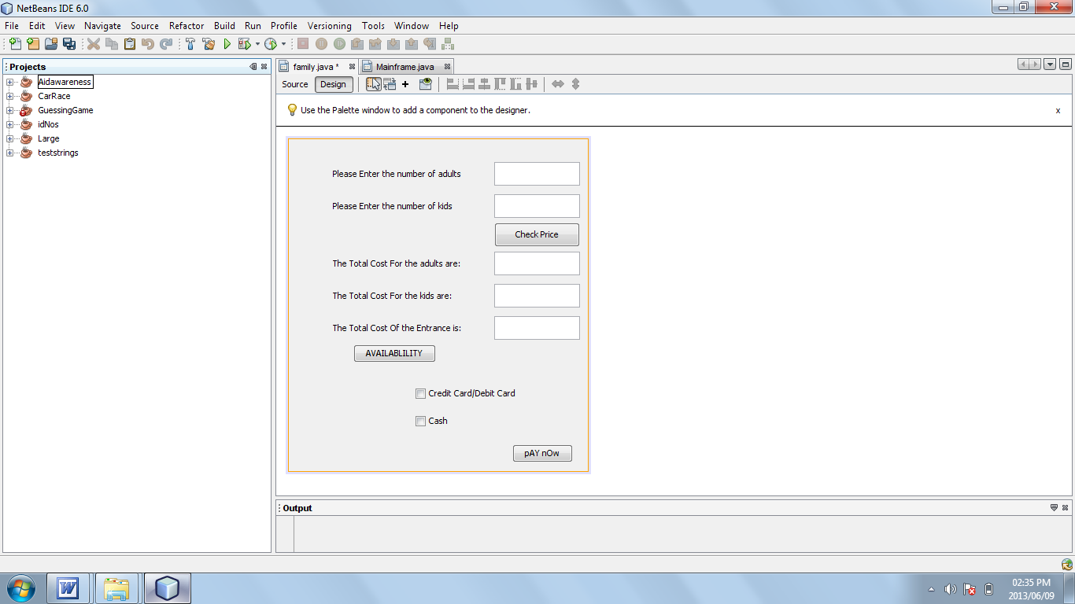

6.1 In the above screen, there is a GUI component that has been used incorrectly. Identify the incorrectly used GUI component and state why it is incorrect. (2)

The Check boxes – check boxes allow user to select more than one box at a time. In the GUI, the user needed to select only one option.
6.2 Comment on the layout of the above GUI (2)
The is no heading, the buttons are not aligned, not all buttons inform the user. The text on the buttons differ.

6.3 Answer the questions on the coding below:

1 | Double adult1 =Double.parseDouble(adult.getText());
2 | Double kids1 = Double.parseDouble(kids.getText());
3 | Double adultcost =adult1*25;
4 | Double kidcost =kids1 *10;
5 | Double totalcost = adultcost + kidcost;
6 | TotalAdults.setText (String.valueOf(adultcost));
7 | TotalKids.setText (""+kidcost);
8 | TotalCost.setText (""+totalcost);
9 | Double countpeople = adult1 + kids1;
10 | if (countppl <=100)
11 | {
12 | JOptionPane.showMessageDialog(null,"Welcome To The Nature Reserve");
13 | }
14 | Else
15 | {
16 | JOptionPane.showMessageDialog (null,"Sorry, we are full");
17 | System.exit(0);
 | }

    - What is the purpose of line 10? (2)
It uses the If statement to test a specific criteria( ie: testing to see if the variable countpeople is less than or = to 100)and output if it is true or false
    - What is the function of String.valueOf? (2)
This converts an integer, double data type variable into a string so the output can be shown in a text field
6.4 Computer experts emphasise the importance of the planning stages in programming. One way to plan effectively is to write out an algorithm.

6.4.1 Explain what an algorithm is. (2)
This is a sequence of steps that is followed to solve problems in programming

6.4.2 Explain why an algorithm designed in pseudocode should not be programming language specific. (3)
Pseudocode typically omits details that are not essential for human understanding of the algorithm, such as variable declarations, system-specific code and some subroutines.. The purpose of using pseudocode is that it is easier for people to understand than conventional programming language code.
No standard for pseudocode syntax exists, as a program in pseudocode is not an executable program

TOTAL MARKS: 100

